Lecture 2.1.4
Homogeneous and Particular Solution

Course outcome to be covered:
CO1: Apply and recognized about the Homogeneous and Particular Solution

Linear Homogeneous Recurrence Relation
Linear Homogeneous Recurrence Relations with Constant Coefficients: The equation is said to be linear homogeneous difference equation if and only if R (n) = 0 and it will be of order n. The equation is said to be linear non-homogeneous difference equation if R (n) ≠ 0.
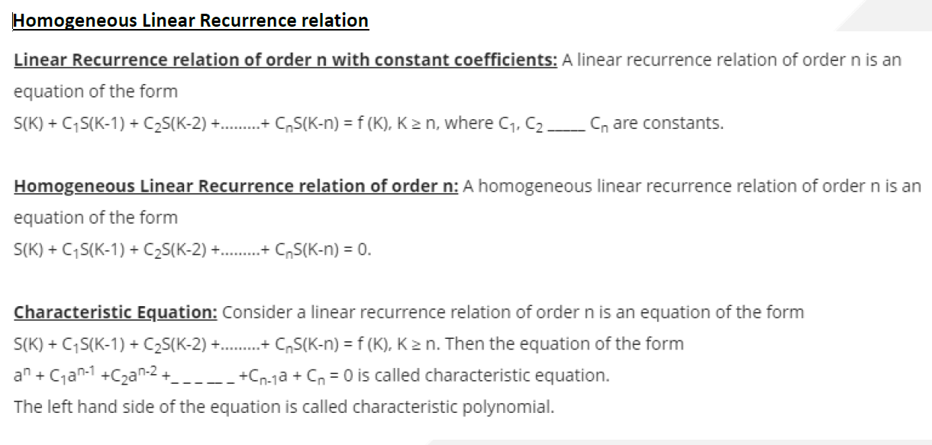
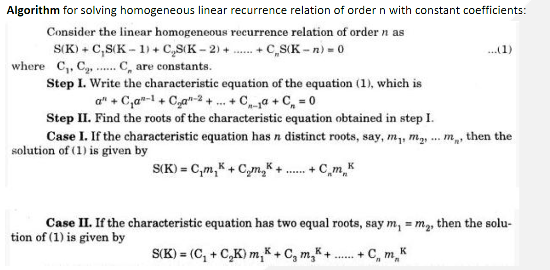

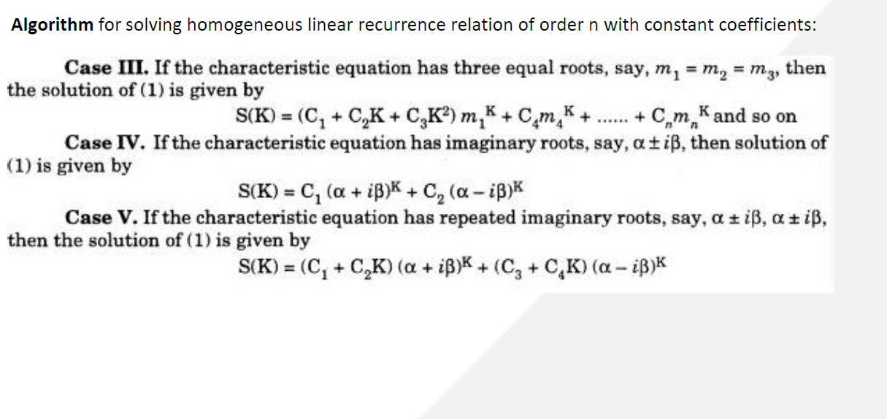
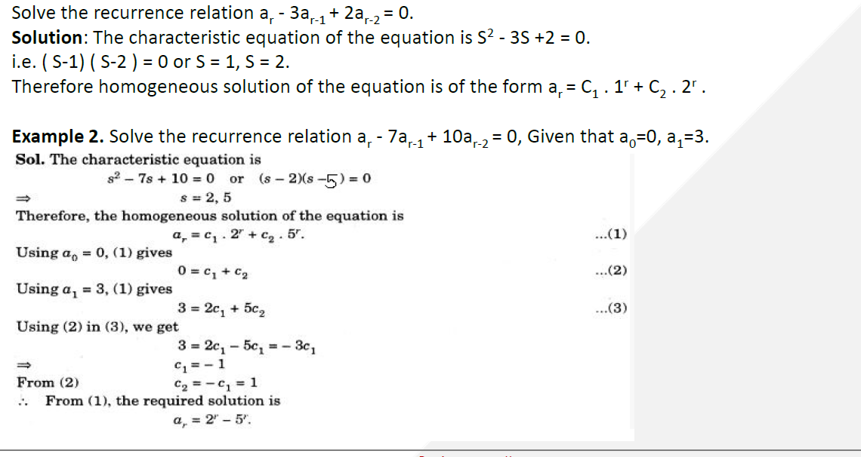

Particular Solution
We can find the particular solution of the difference equation when the equation is of homogeneous linear type by putting the values of the initial conditions in the homogeneous solutions.
Example 1: Solve the difference equation 2a_{r}-5a_{r-1}+2a_{r-2}=0 and find particular solutions such that a₀=0 and a₁=1.
Solution: The characteristics equation is 2s²-5s+2=0
(2s-1)(s-2)=0
s = and 2.
Therefore, the homogeneous solution of the equation is given by
a_{r(h)}= C₁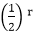+C₂ .2^{r}..........equation (i)
Putting r=0 and r=1 in equation (i), we get
a₀=C₁+C₂=0...........equation (a)
a₁= C₁+2C₂=1...........equation.(b)
Solving eq (a) and (b), we have
C₁=-and C₂=
Hence, the particular solution is
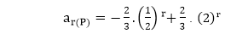
Example 2: Solve the difference equation a_{r}-4a_{r-1}+4a_{r-2}=0 and find particular solutions such that a₀=0 and a₁=6.
Solution: The characteristics equation is
s²-4s+4=0 or (s-2)²=0 s = 2, 2
Therefore, the homogeneous solution of the equation is given by
a_{r(n)}=(C₁+C₂ r).2^{r}.............. equation (i)
Putting r = 0 and r = 1 in equation (i), we get
a₀=(C₁+0).2⁰ = 1 ∴C₁=1
a₁=(C₁+C₂).2=6 ∴C₁+C₂=3⇒C₂=2
Hence, the particular solution is
a_{r(P)}=(1+2r).2^{r}.
The following steps help in finding the particular solution of the differential equation.
- The given differential equation is solved by separating the variables and integrating on both sides to obtain the general solution of the differential equation.
- For differential equations that cannot be solved easily, different methods are employed to find the general solution of the differential equation.
- The general solution of the differential equation contains arbitrary constants, which have to be assigned suitable values to get a particular solution of the differential equation.
- A point is identified to help substitute the values for the arbitrary constants, to obtain the particular solution of the differential equation.
- There can be more than one particular solution for the differential equation, based on the different values of the arbitrary constant.

Particular Solution Vs General Solution Of Differential Equation
A particular solution of the differential equation is derived from the general solution of the differential equation. The differential equation has one general solution, and numerous particular solutions, based on the different values of the arbitrary constants of the general solution.
The general solution of the differential represents a family of curves or lines in the coordinate plane. These curves or lines represent a set of parallel lines or curves, and each of these lines or the curves can be identified as the particular solution of the differential equation.
The general solution of the differential equation is of the form y = ax + b, but the particular solution of the differential equation can be y = 3x + 4, y = 5x + 7, y = 2x + 1. These particular solutions of the differential equation have been obtained by assigning different values to the arbitrary constants a, b in the general solution of the differential equation.
Example 2: Verify if the function y = acosx + bsinx is a particular solution of a differential equation y'' + y = 0?
Solution:
The given function is y = aCosx + bSinx.
Let us take the second derivative of this function.
y' = -aSinx + bCosx
y'' = -aCosx - bSinx
Further we can substitute this second derivative value in the below differential equation.
y'' + y = 0
(-aCosx - bSinx) + (aCosx + bSinx.) = 0
-aCosx - bSinx + aCosx + bSinx. = 0
-aCosx + aCosx -bSinx +bSinx = 0
Therefore, the function y = acosx + bsinx is a solution of a differential equation y'' + y = 0.

eBook Discrete Mathematics :
https://math.libretexts.org/Bookshelves/Combinatorics_and_Discrete_Mathematics/Applied_Discrete_Structures_(Doerr_and_Levasseur)/08%3A_Recursion_and_Recurrence_Relations/8.03%3A_Recurrence_Relations
video link : https://www.youtube.com/watch?v=7mhvA5L7KqY

